**PRN212 Assignment 01**

**Building a Sales Order Management System**

**using WPF and LINQ**

# 1. Introduction

A **Sales Management System** (SMS) helps businesses manage customers, employees, products, and orders efficiently. It tracks the inventory, records orders, calculates totals, and manages customer interactions. Your task is to implement a simplified version of such a system, named **Lucy_SalesData**.

The main modules include:

* **Customer Management**: View, add, edit, and delete customer information.
* **Product Management**: Manage product information, including stock and prices.
* **Order Processing**: Create and manage orders, including order details, employee handling, and customer information.

You will use a simplified data model (in-memory database using List<T>) that includes:

* **Customers** (CustomerID, CompanyName, ContactName, ContactTitle, Address, Phone)
* **Products** (ProductID, ProductName, CategoryID, UnitPrice, UnitsInStock, etc.)
* **Orders** (OrderID, CustomerID, EmployeeID, OrderDate)
* **Order Details** (OrderID, ProductID, UnitPrice, Quantity, Discount)
* **Employees** (EmployeeID, Name, UserName, Password, JobTitle, etc.)
* **Categories** (CategoryID, CategoryName, Description)

# 2. Assignment Objectives

In this assignment, you will:

* Create a WPF project and Class Library in Visual Studio (.NET8–.NET9).
* Use in-memory collections (List<T>) for storing and managing data.
* Apply **LINQ to Object** for queries and filtering.
* Follow **3-Layer Architecture** (Data Layer, Business Layer, Presentation Layer).
* Apply **MVVM pattern** for UI logic separation.
* Implement **Repository** and **Singleton** patterns.
* Add full **CRUD operations** and **searching** functionality.
* Validate data types for all fields.
* Run and test the WPF application.

# 3. Main Functions

* **Admin Role**

Employee login by Username and Password

* **Manage Customers**: Add, update, delete, and search.
* **Manage Products**: Add, update, delete, and search.
* **Create and View Orders**: Include product details, discount, employee handling.
* **Reports**: Generate statistics on orders by time period, sorted descending.
* **Customer Role**

All tasks, use phone instead username and password to do:

* View their order history.
* Edit personal profile.
* Note that: Customer management, Room: Read, Create, Update, Delete and Search actions. Creating and Updating actions must be performed by popup dialog. Delete action always combines with confirmation.

# 4. Note

* You must use **Visual Studio 2022 or above (.NET8/.NET9), MSSQL Server 2012 or above** for your development tools.
* To do your program, you must use **Windows Presentation Foundation. Note that** *you are not allow to connect direct to data source from WPF, every database connection must be used through Repository and Data Access Objects.*
* Create Solution in Visual Studio named **StudentName_ClassCode_A01.sln**. Inside your Solution, the Project WPF must be named: **StudentNameWPF.**
* Set the default user interface for your project as **Login** window.

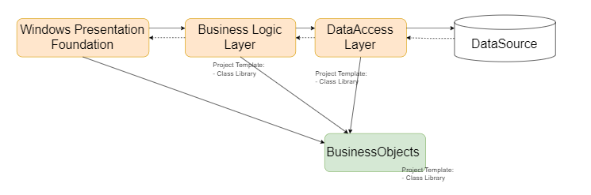

Data Source in this case is the Collection (In-Memory Database)